Bug 3:

**Odds in the game do not appear to be correct:**

Crown and Anchor games have an approximate 8% bias to the house. So the win : (win+lose) ratio should approximately equal 0.42. This does not appear to be the case.

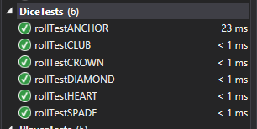

Test Name: rollTestANCHOR

Test Outcome: Passed

Test Duration: 0:00:00.0131149

Test Name: rollTestCLUB

Test Outcome: Passed

Test Duration: 0:00:00.0001335

Test Name: rollTestCROWN

Test Outcome: Passed

Test Duration: 0:00:00.0001058

Test Name: rollTestDIAMOND

Test Outcome: Passed

Test Duration: 0:00:00.0001506

Test Name: rollTestHEART

Test Outcome: Passed

Test Duration: 0:00:00.0001027

Test Name: rollTestSPADE

Test Outcome: Passed

Test Duration: 0:00:00